­­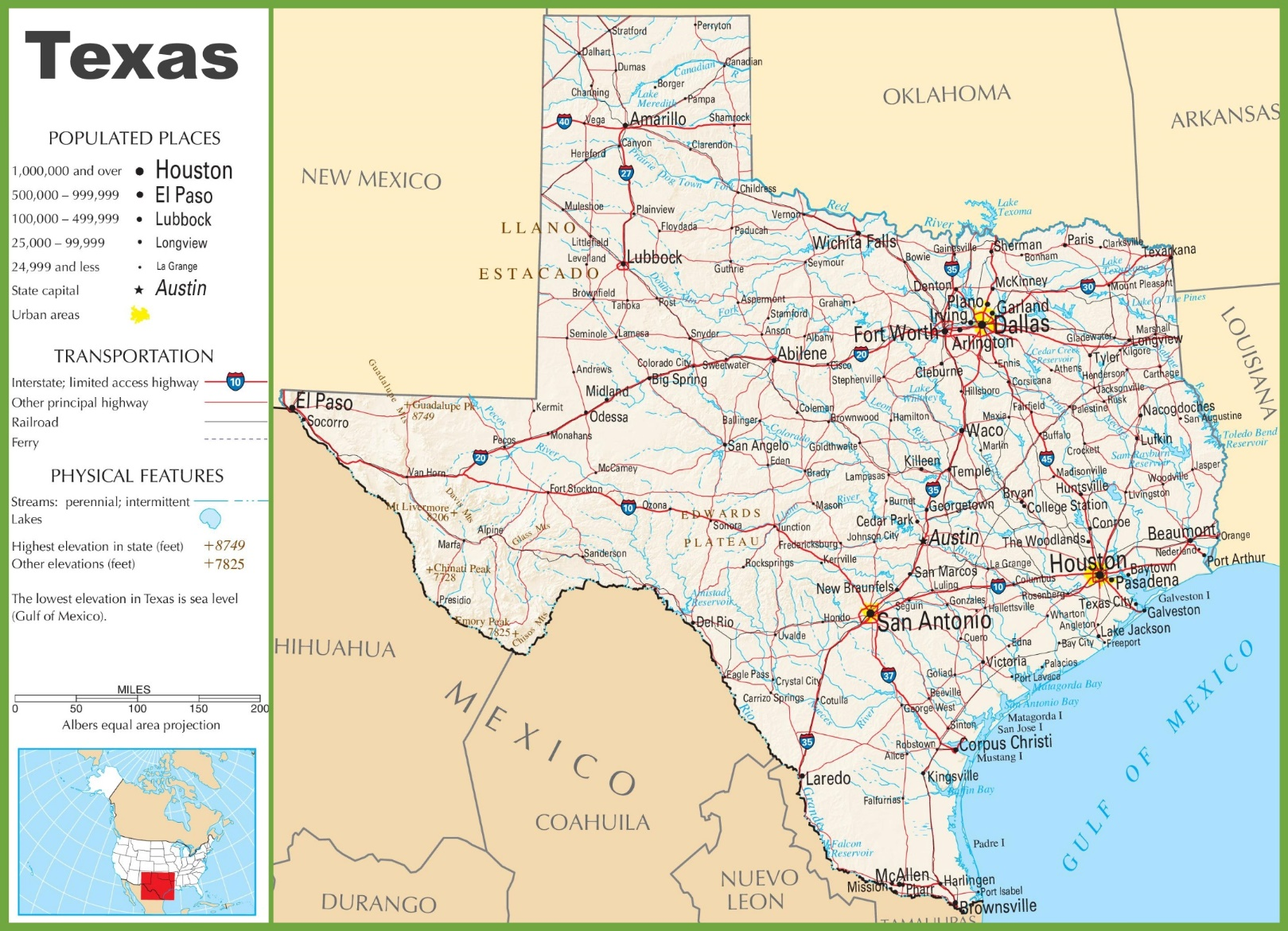

Source: http://ontheworldmap.com/usa/state/texas/texas-highway-map.html